REPORT OF THE 2-DAY CAPACITY BUILDING WORKSHOP ORGANIZED BY THE FEDERAL MINISTRY OF WOMEN AFFAIRS (FMWA) FOR WOMEN IN MICRO, SMALL AND MEDIUM SCALE ENTERPRISES (MSMES) IN PLATAUE STATE, HELD AT TREASURE HOTELS JOS, PLATEAU STATE FROM 25TH TO 26TH SEPTEMBER, 2020.
1.0 Introduction:
1.1 The Micro, Small and Medium Scale Enterprises (MSMEs) play significant role as the engine of economic development, industrialization and transformation of a country. Therefore, the engagement of women in MSMEs will enable improved income generation and redistribution, create employment, drive innovation and encourage growth of indigenous industries. With this view in mind, the Federal Ministry of Women Affairs recognizing the need for women to actively engage in MSMEs organized a two-day capacity building workshop for Nigerian Women Entrepreneurs in Micro, Small and Medium Enterprises in Jos, Plateau State, to impact them with skills to engage in business for self-reliance.
2.0 Objectives:
2.1 The workshop was organized to:
- Provide women in MSMEs with basic entrepreneurship skills to manage and grow their businesses for improved productivity
- Provide start-up capital for women in MSMEs to re-start their businesses affected by Covid-19 Lockdown to better their livelihood.
- Scale up the means of livelihood of women in MSMEs and;
- Scale up wealth and jobs creation among the women in MSMEs for poverty alleviation.
3.0 Participants:
3.1 In attendance at the workshop were: The Honourable Minister (FMWA), The Deputy Governor of Plateau State, Professor Sonni Gwanle Tyoden, Honourable Commissioner, State Ministry of Women Affairs, who also represented the Wife of the Governor and the Permanent Secretary SMWA, Director, Economic Services (FMWA), Director Women Affairs (FMWA), Deputy Director Skills Development (FMWA), and selected staff of FMWA. Also in attendance were the Plateau State Representative of the 50 Million Africa Women Speak project’s (50MAWSP) and other members of 50MASP, 505 women entrepreneurs and Resources persons.
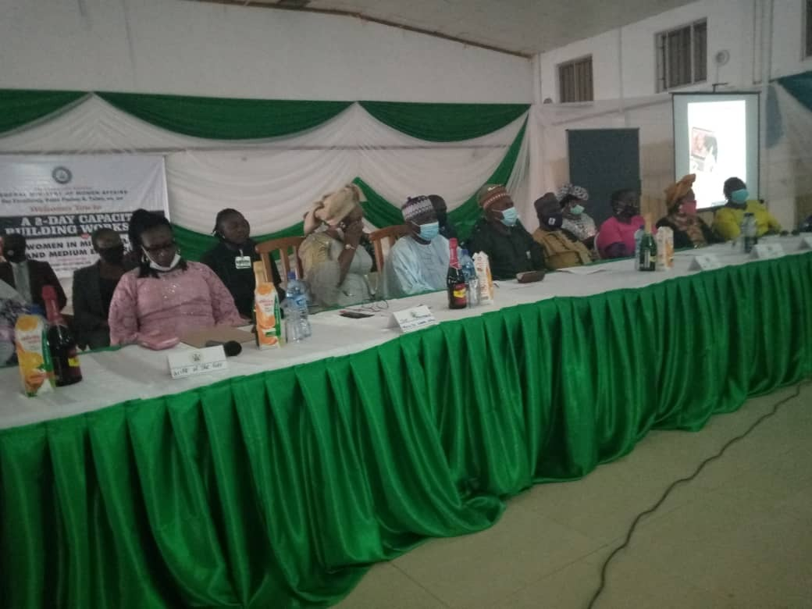
Cross-section of the members of the high table during the workshop

4.0 Opening:
4.1 The Capacity Building Workshop commenced at 10.54am with both Christian and Moslem opening prayers said by two participants.

5.0. Welcome Address:
5.1 The welcome address was delivered by the Honourable Commissioner, State Ministry of Women Affairs Plateau State, Mrs. Rebecca Sambo. She officially welcomed all to the training workshop and appreciated the Honourable Minister, Federal Ministry of Women Affairs (FMWA), Mrs. Dame Pauline Tallen, OFR, KSG, for organizing the programme. She informed the gathering of the inability of the First Lady of Plateau State to attend the event due to another urgent official assignment. She among others recognized the presence of the Permanent Secretary, SMWA, Mrs. Ayika Hassan, the Director Economic Services Department, Mr. Idris Mohammed and other dignitaries at the high table. She implored the beneficiaries of the training workshop to pay rapt attention and assimilate all the training modules put together to empower them.

6.0 Opening Remarks:
6.1. The opening remarks were made by the Director Economic Services Department. He recognized the presence of the Honourable Commissioner, State Ministry of Women Affairs, (SMWA) the Permanent Secretary, SMWA, Hassan and other dignitaries at the high table. He thanked the Honourable Commissioner for making out time to attend the workshop in spite of the short notice. He informed the participants that the resource persons were well informed and knowledgeable to impact them with skills that would be of benefit to them. He said that Plateau State was strategically selected for the programme recognizing the need to capture the women from the area in Ministry’s empowerment schemes.
6.2. The Director Economic Services, Mr. Idris Mohammed also informed participants of the Honourable Minister’s outstanding qualities, including her willingness and desire to engage in programmes that will advance women’s issues and national development. He reminded participants of the existence and prevalence of COVID-19 Pandemic and advised them to take responsibility of their safety and of every person not minding that the sitting arrangement was spaced in line with National Centre for Disease Control (NCDC) COVID-19 protocols.
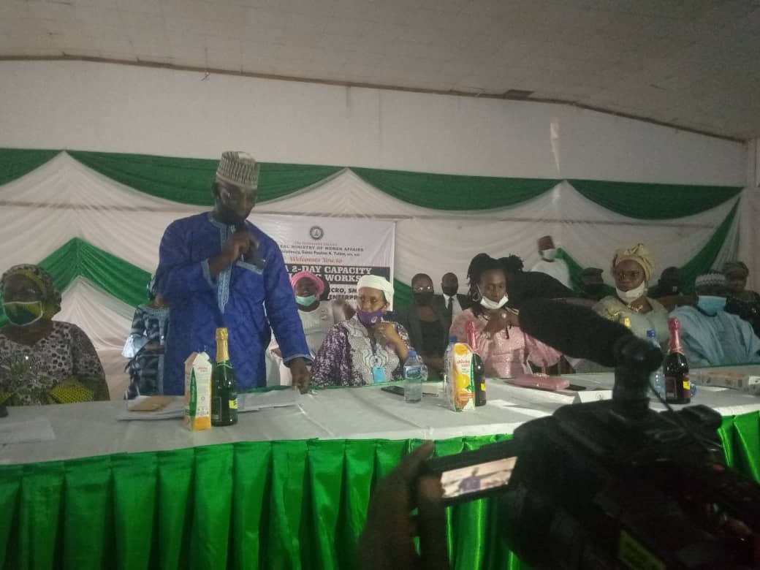
Director, Economic Services Department, delivering opening remarks:

7.0 1st Paper presentation:
7.1 The 1st paper titled: “Identification of Business Opportunities” was presented by one of the resource person, Mrs. Jenifer Ture. She defined Business Opportunity as exploring opportunities that exists within a particular area or environment. According to the presenter, business opportunity is being able to identify those things that are needed or lacking in an area or items that are not sold within a particular area. She stated that the ability to identify those areas of improvement is by further developing sharp ideas which others don’t have.
7.2 She introduced another topic; captioned: “Financial Consumer Rights and Responsibility”. The participants were asked to define rights as the lecture was interactive in nature. Rights was defined as one’s entitlement and responsibility as an obligation or duty. They were told that every customer has rights which must be respected by the seller or business woman to enable her maintain customers and also expand the business. It was explained that financial consumer is the financial end-user of goods and services.
8.0. 2nd Paper Presentation:
8.1 The second paper presentation titled: “Developing the Business Plan for Micro, Small and Medium Enterprises” was also delivered by Mrs. Jennifer Ture. Among the learning objectives of the presentation include:
- Understand what a bankable business plan is
- Know why you need the business plan
- Know the components of a good business plan
- Strategies for Effective Implementation of the plan
8.2. While the presentation outline is:
- Planning
- What is a Business Plan?
- Why Do You Need a Business Plan?
- Business Plan Contents.
- Executive Summary
- Business overview
- The Marketing Plan
- The Production/Service Delivery Plan
- Organization and Management Plan
- Financial Plan
8.3 The resource person explained that business plan starts from registering a business, identifying the type of business to engage in, opening an account for the business and having account record books. It also entails having a structured guideline to archive a business plan. A business plan according to the resource person is an accumulation of information and decisions made during the planning process of a business which helps an entrepreneur articulate how to execute a great idea.
8.4. She then appealed to the Women to start a business which will position them to earn money to be self-reliant, contribute to family needs and national development.
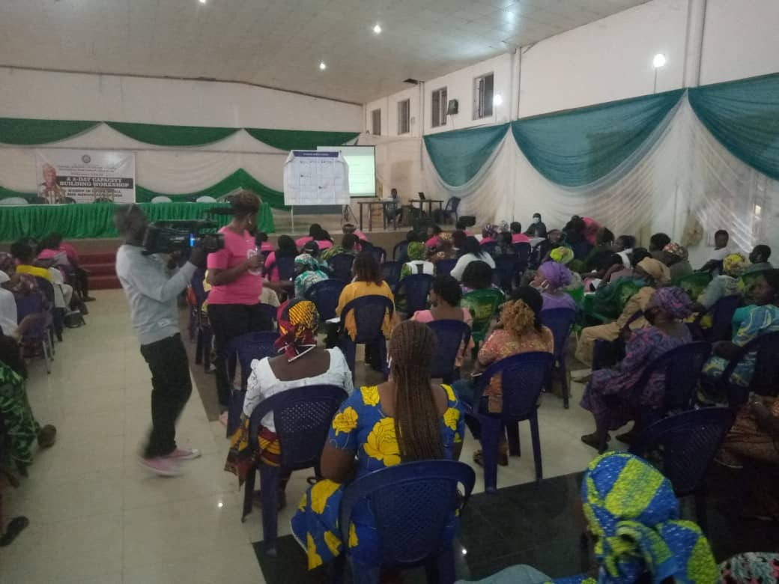
The resource person illustrating some poits to the participants.

9.0 Comments, Questions/Answers:
i. A woman who is engaged in poultry informed that her business always listens to customer needs, and respects their rights and this gives her knowledge to know everything about her business, starting from vaccination, type of feed and other necessary information.
ii. One of the women explained that her business is doing well, but that the lecture will enable her keep record books and bank account.
10.0. Wrap-up
10.1. The day one events came to a close with very important remarks made by the Director, Economic Services Department, FMWA. He challenged the participants to make proper use of the opportunity to learn and internalize all the presentations by the facilitators. He informed that he is an advocate for women, a He-for-She, always ready to champion the course of women and ensure that women’s awareness and consciousness are raised.
10.2 The programme according to him was designed to make the participants grow their businesses. He then advised those who were yet to engage in Business ventures to start one immediately in order to add value to their families and society at large. He said that the event has achieved the intended purpose of creating awareness and informed the women of the need to be productive business wise. The Director further informed that the 50MAWSP is a platform designed to empower women in Africa and noted that women in Nigeria is currently ranking high among women in Africa. He then concluded by urging the Women to use the opportunity to network with each other and challenge themselves on whatever they are doing to achieve success.
11.0. Day Two/Closing Ceremony:
11.1 The workshop started with the recap of activities of day one and thereafter, the 1st Paper presentation titled: ‘Business model Canvas’ (BMC) was delivered by the facilitator - Mrs. Jenifer Ture of the 50MAWSP. She started by saying that BMC is a topic that covers the entire business one does which contains nine building blocks. She further said that the business model canvas is a tool used to visualize all the building blocks when you want to start a business including customer route to market, value proposition to finance.
11.2 Participants were also made to understand that BMC can help entrepreneurs to address specific risk and acquire more information. She took time to explain the nine building blocks to the participants and finally advised them to have a copy of BMC hung in their shops
12.0. Comments, Discussions and Questions:
12.I. A participant sought an advice on how to handle a customer who buys from a trader on credit and subsequently abandoned the supplier to divert to other shops to commence cash purchases. In response to this, the participant was advised to make sure that the client is credit worthy before releasing her goods to such a person. All the participants were equally advised not to give their goods on credit to strangers and to avoid giving more than 10% of their goods on credit.
12.2 Another participant also sought for clarification on what to do concerning a husband who leaves every financial burden to the wife who is an entrepreneur. She was counseled to separate their business fund from the resources to run her family.
13.0 2nd Paper Presentation:
13.1 The 2nd paper presentation titled ‘Personal Financial Planning’ was presented by another Facilitator – Sammie Philips. He began by defining the topic as, ‘The process of meeting individual life goals through proper management of one’s finances. Among the outline of his presentation are:
- Why Plan
- Income age graph
- Ages 30-40
- Ages 40-50
- Ages 50-60
- Moment of Truth
- Failure to plan Financially Results in Vicious Cycle of Poverty
- Financially Stable People

14.0 Arrival of the Honourable Minister FMWA:
14.1 The Master of the Ceremony (MC) announced the arrival of the Honourable Minister of Women Affairs and her entourage and subsequently the arrival of the representative of the Governor of Plateau State, His Excellency, Dr. Simon Bako Lalong ably represented by the Deputy Governor, Professor Sonni Gwanle Tyoden, Her Excellence, the wife of the Governor of Plateau State ably represented by the Honourable Commissioner SMWA Plateau State, Mrs. Rebeca Adamu Sambo, and other dignitaries. The National Anthem, National Pledge and the women’s anthem was recited one after the other. This was followed with the introduction of the dignitaries at the high table.

15.0. Welcome address of the First Lady of Plateau State:
15.1The welcome address of the First Lady of Plateau State was read by the Honourable Commissioner of SMWA. She started by welcoming all the participants to the event and said that the training workshop was organized for Plateau Women to learn things that will help them to grow their businesses. She then appreciated the Hon. Minister, Federal Ministry of Women Affairs for her achievements so far on ensuring the welfare of women especially those in Plateau State and for organizing the programme in the state. She urged the participants to make good use of the opportunity to better their lives and contribute to their family welfare and national development.
15.2 This was followed by a briefing to the Honourable Minister by the State Representative of the 50MWASP Mrs. Jenifer Ture on the outcomes of the technical session and its impact on women participants This was climaxed by the award presentation by the Plateau State 50MWASP to the Honourable Minister.
16.0 Keynote Address of the Honourable Minister:
16.1 While delivering her keynote address, the Honourable Minister expressed her pleasure to be present in the event. She informed the gathering that FMWA is the apex government Machinery that is saddled with the responsibility to train Women. She noted that the training workshop is one of her Ministry’s role to build the capacity of Nigerian Women Entrepreneurs in Micro, Small and Medium Enterprises. While speaking, she appreciated the Governor of Plateau State and his wife, the Honourable Commissioner SMWA, the Permanent Secretary SMWA, the Director Economic Services Department, Mr. Idris Mohammed, overseeing Deputy Director Women Development, Mrs. Funke Oladipo, amongst others.
16.2 She further appreciated the leader of the disabled persons in the state and other disabled persons for participating at the event. She expressed her pleasure to be in their midst to speak on issues concerning women’s welfare and empowerment. She informed that women everywhere should be empowered to engage in Micro, Small and Medium enterprises or any entrepreneurship activity to be able to support their families and the nation at large. She announced that by the end of her current nationwide advocacy visit, about 100 million women will be lifted out of poverty.
16.3 She further said that the programme was part of Ministry’s intervention aimed at empowering women at all levels to ensure that their status is lifted. She urged the women to put in their best to make good use of the training to better themselves. She appreciated the 50MAWSP group for their good works at empowering women and urged them to continue with the pace in the State.
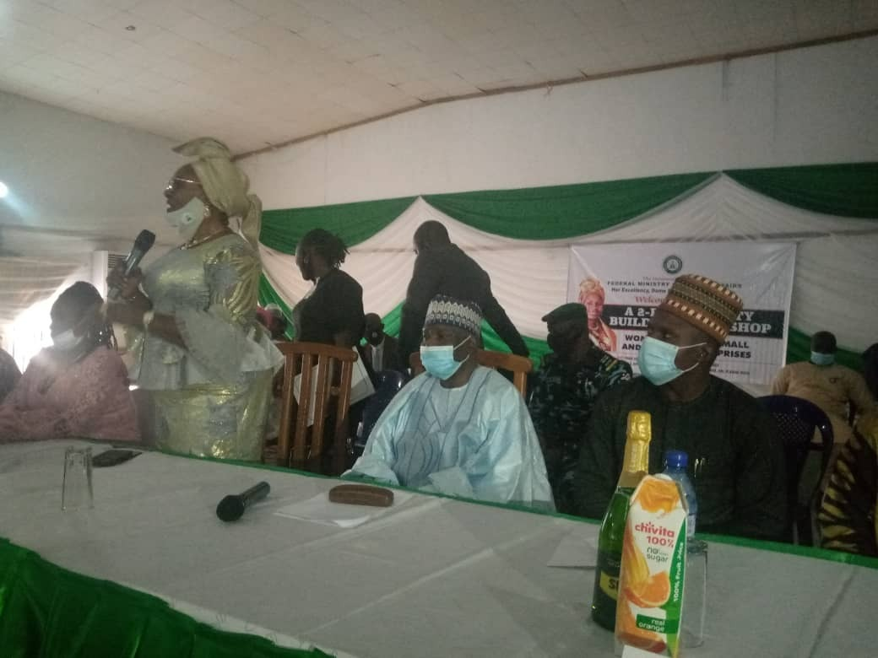
The H/M presenting her Key Note Address during the training programme.
16.4. The Governor of Plateau State represented by Deputy Governor, professor Sonni Gwanle Tyoden Delivered the Governor’s speech. He appreciated the Honourable Minister for all her effort at empowering women in Nigeria. He congratulated the participants and urged them to make use of the opportunity to improve on their skills in order to add value to their families and development of Nigeria in general.
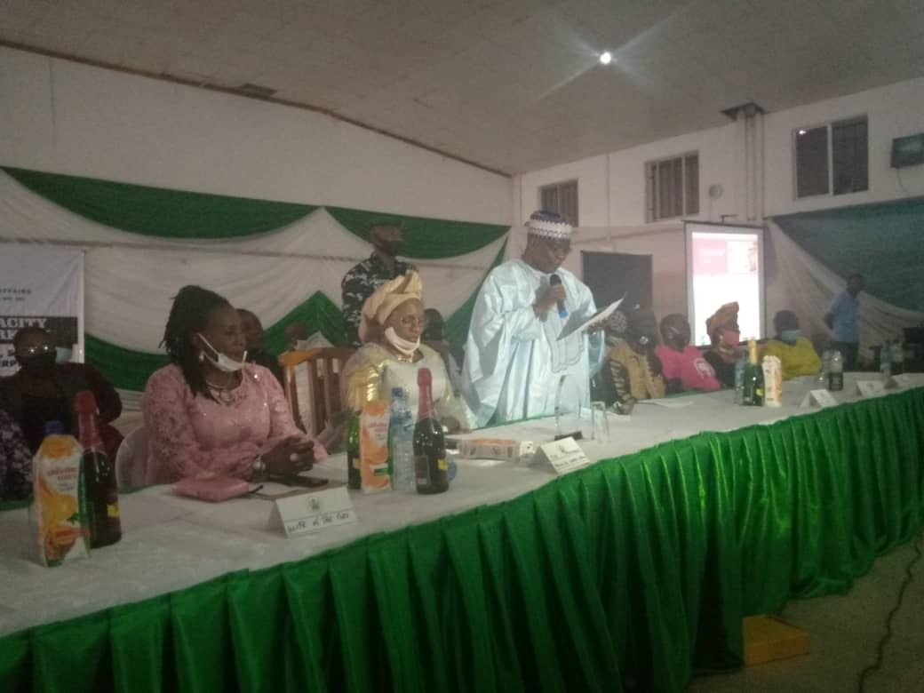
The Governor’s speech being presented by his representative - the Deputy Governor, Professor Sonni Gwanle Tyoden.
17.0 Presentation of seed money to Women Entrepreneurs:
17.1 The participants were presented with seed money by the Deputy Governor and the Honourable Minister. The distribution was first made to ten physically challenged Women Entrepreneurs before other beneficiaries were reached with seed money to boost their business ventures. At the end of the exercise, Rhoda Dashi, on behalf of the recipients thanked the Honourable Minister for her kind gesture. She went down the memory lane to recount a number of things the Hon. Minister has done for the physically challenged in Plateau State and promised that they will always remember her for those things and finally prayed that God will bless the Hon. Minister.
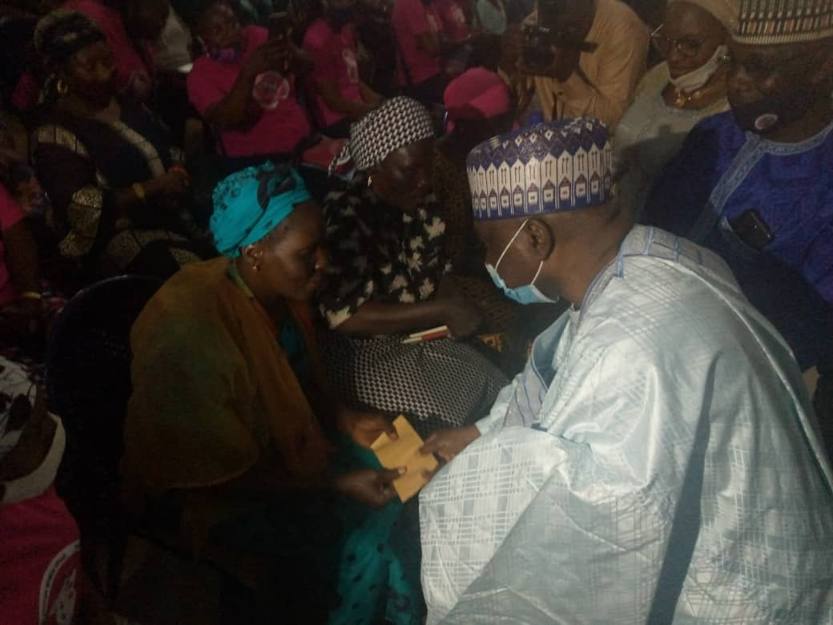
Distribution of the seed money to the beneficiaries

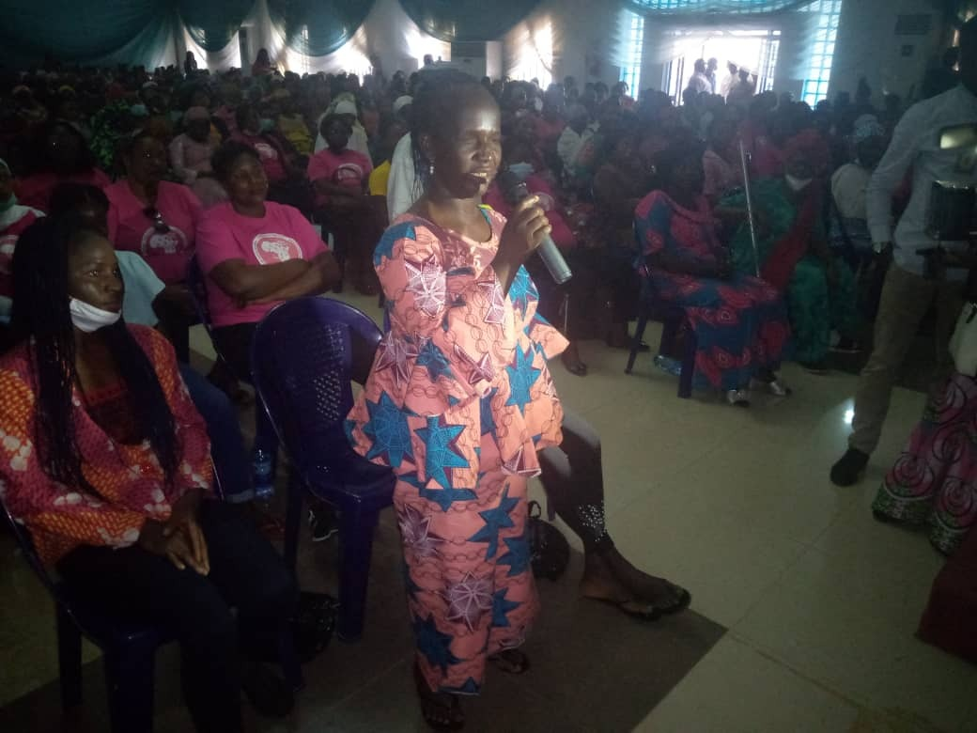
Rhoda Dashi appreciating the H/M on behalf of the pysicall challenged and all the recipients

18.0 Vote of thanks:
18.1 The vote of thanks was delivered by the Director Economic Services. He began by saying that his assignment was made simple by the erudite presentation by the Hon. Minister He thanked the Almighty God for making the event possible. He also appreciated the Minister for her efforts and making the programme a success. He thanked the Deputy Governor of Plateau State, the Honourable Commissioner SMWA, and the Permanent Secretary SMWA.
18.2 He further appreciated the 50MWASP Plateau State chapter for their support and collaboration. He also thanked the participants for the enthusiasm they displayed during the training workshop. He thanked the media for covering the event and said that he was looking forward to seeing them in future programmes. The Director then appreciated the people of the state for their hospitality and said that he will always remember Plateau state as a home of peace, tourism and hospitality. He finally thanked all for coming and wished every one present journey mercies back to their various destinations.
19.0 Closing:
19.1 The 2-day Capacity Building Workshop ended at about 4:45pm on the second day.

Report by:
Nnabuike Peter .U. and Orji L. Nnanna

14TH October, 2020.

EXECUTIVE SUMMARY REPORT OF THE 2-DAY CAPACITY BUILDING WORKSHOP ORGANIZED BY THE FEDERAL MINISTRY OF WOMEN AFFAIRS (FMWA) FOR WOMEN IN MICRO, SMALL AND MEDIUM SCALE ENTERPRISES (MSMES) IN PLATEAU STATE, HELD AT TREASURE INN HOTELS JOS, PLATEAU STATE FROM 25TH TO 26TH SEPTEMBER, 2020.
1.0 Introduction:

1.1 The Micro, Small and Medium Scale Enterprises (MSMEs) play significant role as the engine of economic development, industrialization and transformation of a country. Therefore, the engagement of women in MSMEs will enable improved income generation and redistribution, create employment, drive innovation and encourage growth of indigenous industries. With this view in mind, the Federal Ministry of Women Affairs recognizing the need for women to actively engage in MSMEs organized a two-day capacity building workshop for Nigerian Women in Micro, Small and Medium Enterprises in Jos, Plateau State, to impact women entrepreneurs with skills to engage in business for self-reliance.

2.0 Objectives:
2.1 The principal objectives of the workshop among others were to provide women in MSMEs with basic entrepreneurship skills to manage and grow their businesses for improved productivity, provide start-up capital for women in MSMEs to re-start their businesses affected by Covid-19 Lockdown to better their livelihood and scale up the means of livelihood of women in MSMEs.

3.0 Participants:
3.1 In attendance at the workshop were: The Honourable Minister (FMWA), The Governor of Plateau State presented by the Deputy Governor of Plateau State, Professor Sonni Gwanle Tyoden, Honourable Commissioner, State Ministry of Women Affairs, who also represented the Wife of the Governor and the Permanent Secretary SMWA, Director, Economic Services (FMWA), Also in attendance were the Plateau State Representative of the 50 Million Africa Women Speak project’s (50MAWSP), 400 women entrepreneurs and Resources persons and other staff of FMWA.

Day One – Friday, 25th September, 2020

4.0. Opening:
4,1 The Capacity Building Workshop commenced at 10.54am with both Christian and Moslem opening prayers by two participants. Welcome address and opening remarks were delivered by the Honourable Commissioner, State Ministry of Women Affairs plateau state, Mrs. Rebecca Sambo and Director, Economic Services Department, FMWA respectively. They welcomed participants to the workshop and urged them to make maximum use of the opportunity to acquire skills to grow their businesses and contribute to the welfare of their families.

5.0 Technical Session:
5.1 During the technical session, four papers were presented, they include:
- Identification of Business Opportunities
- Financial Consumer Rights and Responsibility
- Developing the Business Plan for Micro, Small and Medium Enterprises
- understanding what a bankable business plan is
Paper presentations were followed with comments, questions and answers to drive home the salient points of the training workshop.

6.0 Day Two – Saturday, 26th September, 2020
6.1 Activities of the day two of the workshop started with the recap of activities of day one. Thereafter, two Papers were presented titled: ‘Business model Canvas’ (BMC) and ‘Personal Financial Planning’. Addresses were presented by Honourable Minister and other Dignitaries at the workshop. The Honourable Minister received an award from the Plateau State chapter of 50MWASP.
The climax of the workshop was the presentation of seed money by the Honourable Minister to the Women Entrepreneurs to boost their businesses.

7.0. The workshop ended at about 4:45pm with the closing remarks made by the Director, Economic Services, Mr. Idris Mohammed. The second stanza of the National Anthem was taken as a closing prayer.

8.0. Observation:
i. The training workshop was well attended as the participants were very eager to learn business secrets that will help them to expand their business ventures.
ii. Many questions asked by the Women entrepreneurs on some challenging business tasks were answered appropriately by the seasoned Facilitators.
iii. The training workshop served as a critical tool for women empowerment and an easy means of achieving Nigeria’s economic development, considering the devastating effects of COVID-19 Pandemic.
iv. The training workshop was rated high and very successful.

9.0 Recommendation:
9.1 In view of paragraph 8, it is recommended that the training workshop be replicated in other geopolitical zones to empower women with entrepreneurial skills which will position them to be self-reliant, contribute to the welfare of their families and national development.

Nnabuike Peter .U.,
PASWO 1 (MC)
Orji L. Nnanna (SCDO)

14TH October, 2020.

